ASP - MVC - Ticket booking Problem

Nancy is working in a popular paradise hall, which is the best event organizing, planning, coordinating and managing company in Mumbai. The Manager of the Popular Paradise hall decided to develop a web based application for booking tickets for a stage show. He has given that work to Sarra. But she doesn't know how to develop a web application with a database connection. Help her to develop a ticket booking application.

Write an ASP program for the ticket booking application which displays the ticket booking details and if ticket booked successfully then display **Ticked Booked Successfully!!!.**Display the ticket details by updating the ticket count and if the requested number of tickets not available display **Requested number of tickets not available**.

Consider the class **SeatingSection**with the following attributes

|  |  |
| --- | --- |
| **Data Type** | **Attributes** |
| int | _id |
| string | _seatingType |
| double | _ticketCost |
| int | _numberOfTickets |

The methods for **getters**, **setters** and **constructors** are given in the template code.  
  
Consider the class **SeatingSectionDAO** and define the below methods to handle all database related operations

|  |  |  |
| --- | --- | --- |
| **S.No** | **Method Name** | **Description** |
| 1 | public List<SeatingSection > GetAllSeatingSection() | This method will return a list of SeatingType objects. |
| 2 | public boolean BookTicket(int seatingType,int ticketCount) | This method will return true if ticket booked successfully. If number of tickets are not available it will return false. After booking, ticket it must be updated in the database. |

**Page Flow :**

1. Create **Home**controller **Index**action which displays the seating section details and a **book** button.  
2. By clicking the **book** button, the request must be forwarded to **Update** action with show name, seating type, number of tickets as input and two buttons named **book** and **cancel**. (Seating type must be given in drop down box, keep option value for Platinum, Gold, Silver as 1, 2, 3 respectively).  
3. By clicking **cancel** button the request must be forwarded to the **Index** action.  
4. By clicking the **book** button the request must be forwarded to **Update**action. If the number of tickets is available, then update the ticket count and forward to **Index** action which displays the success message as provided in the screenshot. If tickets not available, then display the message as provided in the screenshot.

**Note: Make sure the UI constraints like element names, id's, UI design, element order, alignment and field labels should be followed as specified in the mock-up screen.**

**Screenshot 1 (Index.cshtml) :**

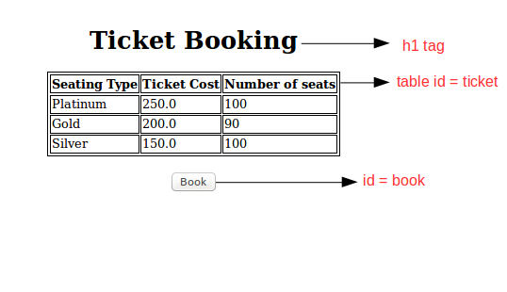

**Screenshot 2 (Book.cshtml) :**

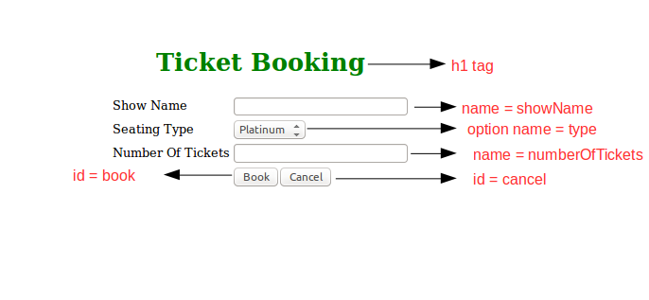

**Screenshot 3 (Index.cshtml) :**

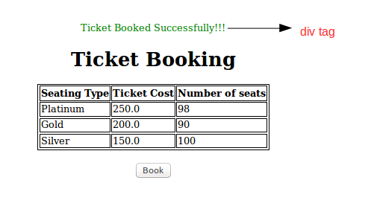

**Screenshot 4 (Index.cshtml) :**



